OUM

AN.100 Analysis Specification

Universal Assistance

Conciliación de Tarjetas-Incorporar Recibos Revertidos

Req # 3063

Author: Braian Christiansen

Creation Date: Junio 22 2017

Last Updated: Junio 22 2017

Document Ref: No aplica

Version: 1

1. **Title, Subject, Last Updated Date, Reference Number**, **and** **Version** are marked by a Word Bookmark so that they can be easily reproduced in the header and footer of documents. When you change any of these values, be careful not to accidentally delete the bookmark. **You can make bookmarks visible by selecting Tools->Options…View and checking the Bookmarks option in the Show region.**

**Approvals:**

|  |  |
| --- | --- |
| <Approver 1> |  |
| <Approver 2> |  |

1. To add additional approval lines, press [Tab] from the last cell in the table above.
2. You can delete any elements of this cover page that you do not need for your document.

# Document Control

## Change Record

2

| Date | Author | Version | Change Reference |
| --- | --- | --- | --- |
| 22-06-2017 | Braian Christiansen | 1 | No Previous Document |
|  |  |  |  |
|  |  |  |  |
|  |  |  |  |

## Reviewers

| Name | Position |
| --- | --- |
|  |  |
|  |  |
|  |  |
|  |  |

Contents

1 Document Control ii

1.1 Change Record ii

1.2 Reviewers ii

2 Overview 1

2.1 Business Objetives 1

2.2 Major Features 1

2.3 Definitions 1

2.4 Mapeo 3

2.5 Examples 3

2.6 Business Rules 3

2.7 Assumptions 3

3 User Interface Descriptions 4

3.1 Surface Feature Descriptions 4

3.2 User Interface Flow Descriptions 4

4 Data and Behavior Analysis 5

4.1 Data Analysis 5

4.2 Behavior Analysis 5

5 Interface Analysis 6

6 Open and Closed Issues 7

6.1 Open Issues 7

6.2 Closed Issues 7

1. To update the table of contents, put the cursor anywhere in the table and press [F9]. To change the number of levels displayed, select the menu option Insert‑>Index and Tables, make sure the Table of Contents tab is active, and change the Number of Levels to a new value.

# Overview

Este documento detalla la corrección que se debe realizar en el proceso de Conciliación de Tarjetas de AR, el cual no está recuperando las líneas Revertidas de los recibos.

1. The intent is to remove ambiguity from requirements as specified in the Use Case Package. Reference the **Package Diagram** within the Architecture Description (RD.130) to identify the package for which this Analysis Specification applies and the Use Cases that the package contains,

## Business Objetives

El objetivo de esta corrección es lo lograr que las líneas Reversadas de los recibos, que hoy en día quedan excluidas, queden finalmente incluidas, y no haya faltantes.

Por otro lado, se modificará la marca que se utiliza hoy en día para no recuperar dos veces el mismo recibo. Actualmente, esta marca se encuentra a nivel cabecera de Recibo. El objetivo es lograr que esta marca se ubique en el Historial de Recibos, para poder distinguir las líneas Remitidas de las Reversadas.

1. This section describes the mapping between this package or use case and the business requirements that have been identified in RD.001 Business and System Objectives. Only list objectives that are impacted by this use case or Use Case package.

## Major Features

## Definitions

A continuación se detallarán las especificaciones a tener en cuenta para hacer los cambios mencionados anteriormente:

1. **Agregar lógica para Recibos Reversados**

Actualmente el concurrente solamente incluye las líneas del Historial de recibos en estado Remitido.

Los cambios a realizar son:

1. Incluir en el query principal del concurrente, la lógica necesaria para que no sólo recupera las líneas de Remitido, sino también las Reversadas.

|  |  |
| --- | --- |
| Campo | Tabla |
| Status | ar_cash_receipt_history |

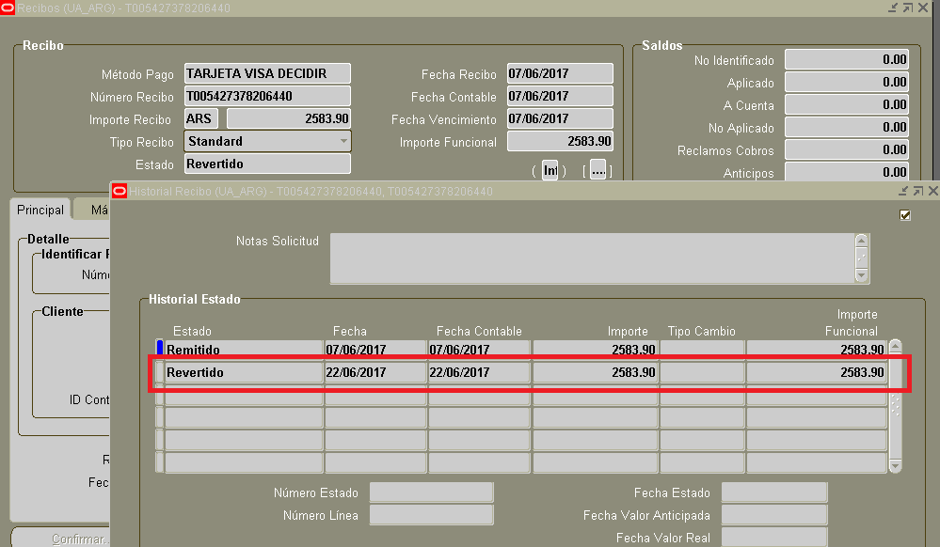

1. **Cambiar marca de Recibos nivel Historial.**

Actualmente el concurrente XX AR Archivo Conciliacion de Tarjetas, al ejecutarse, marca la cabecera de los Recibos. De esta manera, si tenemos un Recibo que solamente posee un línea de Remitido en su historial, y posteriormente ejecutamos el proceso, este marcará en su totalidad el Recibo, por lo cual, en caso que luego de la ejecución el concurrente, se realice una Reversión de la línea del Recibo, esta no será tomada en cuenta para una nueva ejecución del concurrente.

Los cambios a realizar son:

1. Cambiar la marca del Recibo. La misma no debe ser a nivel cabecera, sino a nivel Historial.

|  |  |  |
| --- | --- | --- |
| Cambios | Campo | Tabla |
| Actual | **Attribute1** | Ar_cash_receipts_all |
| Futuro | **Attribute1** | ar_cash_receipt_history |

1. List the Terms that are specific to this Use Case Package from the Glossary (RD.042).

## Mapeo

1. This section defines the User’s interaction with the system interface, and all other collaborating actors (systems, human, etc.).   
     
   Include references (links) to the all the Use Case Specifications (RA.024) for each use case included in this package.

## Examples

1. If available, you may include examples with actual data to help the reader understand the functionality and flow.

## Business Rules

1. The intent of this section is to consolidate, define, and describe (or reference) the business rules that correspond to the Use Cases contained within this package.   
     
   You may reference specific business rules in the Business Rules Analysis (AN.070), if available.   
     
   Business rules may also be documented in the ***Related Information*** section of the applicable Use Case Specification (RA.024) work products.

No Aplica

## Assumptions

No Aplica.

# User Interface Descriptions

1. The intent of this section is to describe any user interface features – including forms, reports, and user interface storyboard flows – that apply to this Use Case Package.   
     
   It is important not to design the screens and reports but simply to understand the user interface elements that will be required. You should make use of wireframes or prototypes developed in the User Interface Analysis (AN.090) and Conceptual Prototype (IM.005).

No Aplica

## Surface Feature Descriptions

1. List and describe the surface feature elements – form and report wireframes or UI feature lists – that are required to support the Use Case Package.   
     
   Surface Features described in the applicable User Interface Analysis (AN.090) may be referenced or reproduced here. You may also include or reference applicable Conceptual Prototype (IM.005) work product.

## User Interface Flow Descriptions

No Aplica

1. Describe any user interface flows – storyboards – that apply to this Use Case Package.   
     
   You should include or reference all of the applicable user interface flow descriptions (storyboards) documented in the User Interface Analysis (AN.090) and Conceptual Prototype (IM.005) work products.

# Data and Behavior Analysis

1. The intent of this section is to capture all of the data attributes and behavior associated with each of the Use Cases in the Use Case Package. Data can include Entity, attribute, min, max default values and comments, while Behavior can include operations, additional attributes, associations, roles, responsibilities, specializations and generalizations for each Use Case. The standard and recommended approach is to use a UML class diagram to capture and express this information.  
     
   **UML Approach**  
   Because UML Class Diagrams capture both Data and Behavior (operations), you should include or reference the **Analysis Class Diagram** created in AN.050 Analyze Data and AN.060 Analyze Behavior. This diagram will provide Data and Behavior analysis information about the Use Case Package. In this case, you may delete the individual Data and Behavior subsections provided below.  
     
   **Non-UML Approach**  
   If you are not using UML, you may include summary information in this section then use the separate Data and Behavior sections below. For detailed instructions, please see the notes included in those sections and review the Analyze Data (AN.050) and Develop Analysis Specification (AN.100) task guidelines.

## Data Analysis

1. Use this section if you are **not** using a UML class diagram to capture data and behavior for your use case package. Otherwise, this section may be deleted.  
     
   The intent of this section is to capture all of the data attributes associated with each of the Use Cases required by this Use Case Package. Data can include entity, attribute, min, max, default values, and comments. You may simply reference or include the Data Analysis (AN.050) for this package. If not available or if the data requirements are very simple, you may use the table below.

| Entity (Class) | Attribute (Data Field) | Minimum Value | Maximum Value | Default Value | Comments |
| --- | --- | --- | --- | --- | --- |
|  |  |  |  |  |  |
|  |  |  |  |  |  |
|  |  |  |  |  |  |
|  |  |  |  |  |  |
|  |  |  |  |  |  |
|  |  |  |  |  |  |
|  |  |  |  |  |  |
|  |  |  |  |  |  |
|  |  |  |  |  |  |

## Behavior Analysis

1. You should use this section if you are using a non-UML approach and are not employing a UML class diagram to capture data and behavior for your use case package. Otherwise, this section may be deleted.  
     
   The intent of this section is to capture all of the system behavior that is required to support the Use Case Package. This can include operations, additional attributes, associations, roles, responsibilities, specializations and generalizations for each Use Case. You should include or refer to the AN.060 Behavior Analysis when completing this section. You may use a functional decomposition, process mapping, or other notation to express this information.

# Interface Analysis

1. The intent of this section is to describe the all external interfaces from this Use Case Package’s point of view. This includes other use case packages and/or external systems. The intent is to describe the high level exchange of messages and information from the use case package under consideration to any external interfaces. You may refer to or include the Package Diagram and Sequence Diagram from the Architecture Description (RD.130). For simple use case packages, you may use the table below.

The <Use Case Package Name> is dependent on the following components and external systems.

| Use Case Name | External System Name, Component Name, or Service Name | Messages | Frequency | Interface Requirements | Message Parameters (data exchanged) |
| --- | --- | --- | --- | --- | --- |
|  |  |  |  |  |  |
|  |  |  |  |  |  |
|  |  |  |  |  |  |
|  |  |  |  |  |  |
|  |  |  |  |  |  |
|  |  |  |  |  |  |
|  |  |  |  |  |  |
|  |  |  |  |  |  |
|  |  |  |  |  |  |

# Open and Closed Issues

1. Add open issues that you identify while writing or reviewing this document to the open issues section. As you resolve issues, move them to the closed issues section and keep the issue ID the same. Include an explanation of the resolution.  
     
   When this work product is complete, any open issues should be transferred to the project- or process-level Issue Log (Manage focus area) and managed using a project level Issue Form (Manage focus area). In addition, the open items should remain in the open issues section of this work product, but flagged in the resolution column as being transferred.

## Open Issues

| ID | Issue | Resolution | Responsibility | Target Date | Impact Date |
| --- | --- | --- | --- | --- | --- |
|  |  |  |  |  |  |
|  |  |  |  |  |  |
|  |  |  |  |  |  |
|  |  |  |  |  |  |

## Closed Issues

| ID | Issue | Resolution | Responsibility | Target Date | Impact Date |
| --- | --- | --- | --- | --- | --- |
|  |  |  |  |  |  |
|  |  |  |  |  |  |
|  |  |  |  |  |  |
|  |  |  |  |  |  |